Prototype Pattern
# Source: AI Source: Provided by: [Data Path: Persons Table -> ID Column: 1, Name_En Column: Motasem Essam] -> From: [ChatGPT] on [1/23/2026]
The Prototype Pattern creates new objects by copying an existing object, rather than creating from scratch.
👉 Think of it like photocopying a document: you clone an existing object and modify it slightly if needed.

🔑 Key Points
# Source: AI Source: Provided by: [Data Path: Persons Table -> ID Column: 1, Name_En Column: Motasem Essam] -> From: [ChatGPT] on [1/23/2026]
• Enables object cloning without knowing the exact class
• Useful for performance optimization when object creation is costly
• Supports dynamic object creation at runtime

❌ Bad Example
# Source: AI Source: Provided by: [Data Path: Persons Table -> ID Column: 1, Name_En Column: Motasem Essam] -> From: [ChatGPT] on [1/23/2026]
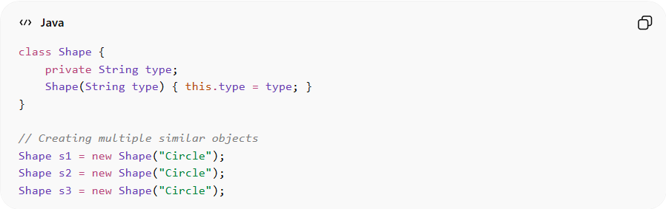
class Shape {
private String type;
Shape(String type) { this.type = type; }
}

// Creating multiple similar objects
Shape s1 = new Shape("Circle");
Shape s2 = new Shape("Circle");
Shape s3 = new Shape("Circle");
Problems:
• Repeated object creation is inefficient
• Client needs to know exact class details
• Hard to create variations dynamically

✅ Good Example
# Source: AI Source: Provided by: [Data Path: Persons Table -> ID Column: 1, Name_En Column: Motasem Essam] -> From: [ChatGPT] on [1/23/2026]
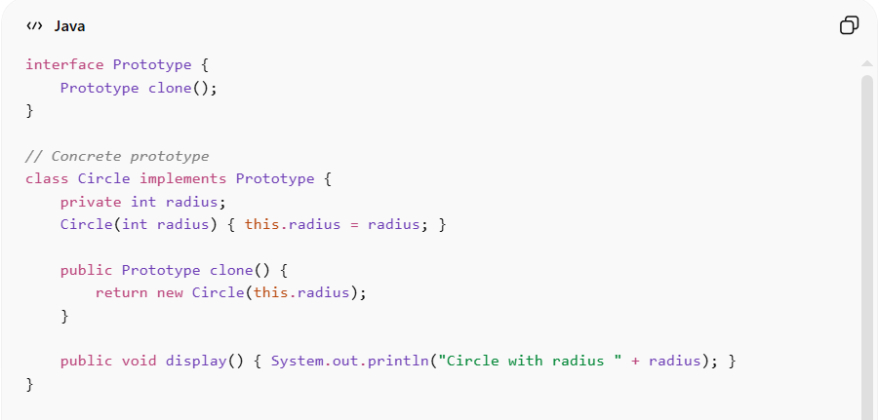
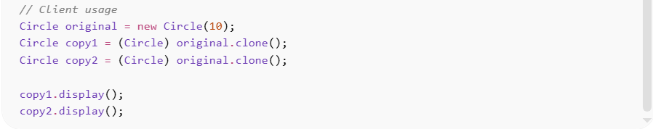
interface Prototype {
Prototype clone();
}

// Concrete prototype
class Circle implements Prototype {
private int radius;
Circle(int radius) { this.radius = radius; }

public Prototype clone() {
return new Circle(this.radius);
}

public void display() { System.out.println("Circle with radius " + radius); }
}

// Client usage
Circle original = new Circle(10);
Circle copy1 = (Circle) original.clone();
Circle copy2 = (Circle) original.clone();

copy1.display();
copy2.display();
Benefits:
• Avoids expensive object creation
• Supports runtime object configuration
• Decouples client from concrete classes
• Easy to produce many similar objects

⚡ Advantages
# Source: AI Source: Provided by: [Data Path: Persons Table -> ID Column: 1, Name_En Column: Motasem Essam] -> From: [ChatGPT] on [1/23/2026]
• Efficient creation of complex objects
• Reduces subclassing when creating multiple similar objects
• Supports dynamic and flexible object creation
• Works well with object pools

⚠️ Disadvantages
# Source: AI Source: Provided by: [Data Path: Persons Table -> ID Column: 1, Name_En Column: Motasem Essam] -> From: [ChatGPT] on [1/23/2026]
• Cloning can be complex for objects with deep references
• Must carefully implement deep vs shallow copy
• Overuse can lead to hidden dependencies

🛠️ Use Cases
# Source: AI Source: Provided by: [Data Path: Persons Table -> ID Column: 1, Name_En Column: Motasem Essam] -> From: [ChatGPT] on [1/23/2026]
• Performance-critical systems – cloning large data structures
• Graphical applications – copying shapes or UI components
• Object configuration templates – preconfigured prototypes for reuse
• Undo/Redo systems – keeping snapshots of objects

